MSDS # CP-301 Revision Date: October 2007 Supercedes: April 2007
Section 1 Chemical Product and Company Identification

PRODUCT NAME: CARUS™ ZPX Well Conditioner
TRADE NAME: CARUS™ ZPX Well Conditioner
SYNONYMS: Proprietary polymeric blend
Manufacturer’s Name:  Carus Phosphates, Inc. | Information: (815) 223-1500 (815) 224-6816 (FAX)  www.caruscorporation.com (Web) salesmkt@carusphosphates.com (Email)
Manufacturer’s Address:  Carus Phosphates, Inc.  315 Fifth Street  Peru, IL 61354, USA | Emergency Telephone:  (800) 435 –6856 (USA) (815) 223-1500 (Other countries)  CHEMTREC® (800) 424-9300 (USA)  (703) 527-3887 (Other countries)

Section 2 Ingredients Information

Material | PEL | TLV | CAS.NO. | EC. NO. | %
Non-hazardous ingredients | No Data | No Data | N/A | N/A | 100

This product contains no toxic chemicals subject to the reporting requirements of Section 313 – Title III of the Superfund Amendments and Reauthorization Act of 1986 and 40 CFR Part 372.
All the components in this product are substances generally regarded as safe ((21 CFR 182) and none could be classified as hazardous according to the WHMIS system. None are listed on the Canadian Ingredient Disclosure List.
Hazard Symbols:
None
Risk Phrases:
22 Harmful if swallowed.
38 Irritating to skin
Safety Phrases:
2 Keep out of reach of children
61 Avoid releases to the environment.

Section 3 Hazards Identification

Hazardous Materials Identification System (HMIS) Ratings:
Health: 1 - Slight
Flammability: 0 - None
Reactivity: 0 - None
Personnel Protective Equipment: goggles, face shield, apron, respirator and proper gloves.
Inhalation:
May cause irritation to the respiratory tract. Symptoms may include coughing and shortness of breath.
Ingestion:
Slight stomach irritation, may cause upset stomach.
Skin Contact:
May cause irritation. May cause inflammation and pain on prolonged contact, especially with moist skin.
Eye Contact:
May cause irritation, redness and pain.
Chronic Exposure:
No specific information found.
Aggravation of Pre-existing Conditions:
No specific information found.
Section 4 First Aid Measures

Eyes:
Immediately flush eyes with large amounts of water for at least 15 minutes holding lids apart to ensure flushing of the entire surface.
Skin:
Immediately wash contaminated areas with water. Remove contaminated clothing and footwear. Wash clothing and decontaminate footwear before reuse.
Inhalation:
Remove person from contaminated area to fresh air.
Ingestion:
Never give anything by mouth to an unconscious or convulsing person. If person is conscious, give large
quantities of water or milk. Seek medical attention immediately.

Section 5 Fire Fighting Measures

NFPA* Hazard Ratings:
Health: 1 = Materials which under fire conditions would give off irritating combustion products (less
than 1 hour exposure). Materials which on the skin could cause irritation.
Flammability: 0 = Materials that will not burn.
Reactivity: 0 = Materials which in themselves are normally stable, even under fire exposure conditions, and
which are not reactive with water.
Special Hazard: None
*National Fire Protection Association 704
First Responders:
Wear protective gloves, boots, goggles, and respirator. In case of fire, wear positive pressure breathing apparatus. Approach incident with caution.
Flash Point: None

Flammable or Explosive Limits: Lower: Nonflammable Upper: Nonflammable
Extinguishing Media: Use large quantities of water. Dike to contain.

Section 6 Accidental Release Measures

Steps To Be Taken If Material Is Released Or Spilled:
Contain spill by collecting the liquid in a pit or holding behind a dam (sand or soil). Absorb with inert media and dispose of properly. Disposal of all materials shall be in full and strict compliance with all federal, state, and local regulations pertaining to phosphates. Flush area with large amounts of water.
Personnel Precautions:
Personnel should wear protective clothing suitable for the task.

Section 7 Handling and Storage

Work/Hygiene Practices:
Wash hands thoroughly with soap and water after handling phosphate solution, and before eating or smoking. Wear proper protective equipment. Remove clothing, if it becomes contaminated.
Ventilation Requirements:
Provide sufficient mechanical and/or local exhaust.
Conditions For Safe Storage:
Protect containers from physical damage. Store in a cool, dry area in closed containers.

Section 8 Exposure Controls and Personal Protection

Respiratory Protection:
In cases where overexposure to dust or mist may occur, use any air purifying, and full face piece respirator with an N-95 or better filter. Engineering or administrative controls should be implemented to control dust.
Eye:
Goggles, or safety glasses with side shields should be worn. Provide eyewash in work area.
Gloves:
Rubber or plastic gloves should be worn.
Other Protective Equipment:
Normal work clothing covering arms and legs, and rubber, or plastic apron should be worn. Caution: If clothing becomes contaminated, wash off immediately.

Section 9 Physical and Chemical Properties

Appearance and Odor: Colorless solution, odorless
Boiling Point, 760 mm Hg: >100 °C
Freezing point, 760 mm Hg: <0 °C
Vapor Pressure (mm Hg): N/A
Solubility In Water in % By Solution: Miscible in all proportions
Percent Volatile by Volume: 90% (as water)
Evaporation Rate: Same as water
Specific Gravity: 1.11± 0.03
pH: 4.5 ± 0.5

Section 10 Stability and Reactivity

Stability: Under normal conditions, the material is stable.
Conditions To Avoid: Do not expose to extreme temperatures
Incompatible Materials: No known materials that are incompatible with this product.
Hazardous Decomposition: When involved in a fire, the material may form toxic fumes of carbon oxides.

Conditions Contributing to Material is not known to polymerize.
Hazardous Polymerization:

Section 11 Toxicological Information

Acute Overexposure:
Irritating to body tissue with which it comes into contact.
Chronic Overexposure:
No known cases of chronic poisoning due to phosphate solutions have been reported.
Carcinogenicity:
None of the components has been classified as a carcinogen by OSHA, NTP, and IARC.
Medical Conditions Generally Aggravated by Exposure:
Solution may cause further irritation of tissue, open wounds, burns or mucous membranes.

Section 12 Ecological Information

None

Section 13 Disposal Considerations

Waste Disposal:
Disposal of all materials shall be in full and strict compliance with all federal, state, and local regulations pertaining to phosphates. Chemical waste generators must determine whether a discarded chemical is classified as a hazardous waste. US EPA guidelines for the classification determination are listed in 40 CFR Parts 261.3.
RCRA P-Series: None listed.
RCRA U-Series: None listed.

Section 14 Transport Information

Not regulated by US DOT, Canada TDG, UN, IMDG, IATA regulations.

Section 15 Regulatory Information

US FEDERAL
TSCA:
All components in this product are listed on the TSCA inventory.
Health & Safety Reporting List:
None of the chemicals in this product are on the Health & Safety Reporting List.
Chemical Test Rules:
None of the chemicals in this product are under a Chemical Test Rule.
Section 12b:
None of the chemicals in this product are listed under TSCA Section 12b.
TSCA Significant New Use Rule:
None of the chemicals in this product have a SNUR under TSCA.
CERCLA Hazardous Substances and corresponding RQs:
None of the chemicals in this product have an RQ.
SARA Section 302 Extremely Hazardous Substances:
None of the chemicals in this product have a TPQ.
SARA Codes:
Acute
Section 313:
None of chemicals in this product are reportable under Section 313.
Clean Air Act:
This material does not contain any hazardous air pollutants.
This material does not contain any Class 1 or Class 2 Ozone depletors.
Clean Water Act:
None of the chemicals in this product are listed as Hazardous Substances under the CWA.
None of the chemicals in this product are listed as Priority Pollutants under the CWA.
None of the chemicals in this product are listed as Toxic Pollutants under the CWA.
OSHA:
None of the chemicals in this product are considered highly hazardous by OSHA.
State:
None of the chemicals in this product are present on state lists from CA, PA, MA, and NJ.
California Prop 65:
California No Significant Risk Level: None of the chemicals in this product are listed.

European/International Regulations
European Labeling in Accordance with EC Directives
Hazard Symbols:
None
Risk Phrases:
22 Harmful if swallowed.
38 Irritating to skin
Safety Phrases:
2 Keep out of reach of children
61 Avoid releases to the environment.
WGK (Water Danger/Protection): None
Canada - DSL/NDSL
All the components are listed on Canada's DSL List.
Canada – WHMIS
None of the components in this product could be classified as hazardous in accordance with the hazard criteria of the
Controlled Products Regulations.
Canadian Ingredient Disclosure List
None of the components in this product are listed on the Canadian Ingredient Disclosure List.

Section 16 Other Information

NIOSH National Institute for Occupational Safety and Health CAS Chemical Abstract Service
MSHA Mine Safety and Health Administration
OSHA Occupational Safety and Health Administration PEL Permissible Exposure Limit
TLV-TWA Threshold Limit Value-Time Weighted Average STEL Short Term Exposure Limit
IARC International Agency for Research on Cancer NTP National Toxicology Program
DSL/NDSL The Domestic Substances and the Non-Domestic Substances List (Canada)
EINECS Inventory of Existing Chemical Substances (European) (EC. No.)
The information contained herein is accurate to the best of our knowledge. However, data, safety standards and government regulations are subject to change and, therefore, holders and users should satisfy themselves that they are aware of all current data and regulations relevant to their particular use of product. CARUS PHOSPHATES, INC. DISCLAIMS ALL LIABILITY FOR RELIANCE ON THE COMPLETENESS OR ACCURACY OR THE INFORMATION INCLUDED HEREIN. CARUS PHOSPHATES, INC.MAKES NO WARRANTY, EITHER EXPRESS OR IMPLIED, INCLUDING, BUT NOT LIMITED TO, ANY WARRANTIES OF MERCHANTIABILITY OR FITNESS FOR PARTICULAR USE OR PURPOSE OF THE PRODUCT DESCRIBED HEREIN. All conditions relating to storage, handling, and use of the product are beyond the control of Carus Phosphates Inc., and shall be the sole responsibility of the holder or user of the product. CARUS PHOSPHATES, INC. is a SUBSIDIARY of Carus Corporation, 315 Fifth Street, Peru, IL
 | Chithambarathanu Pillai  October 2007
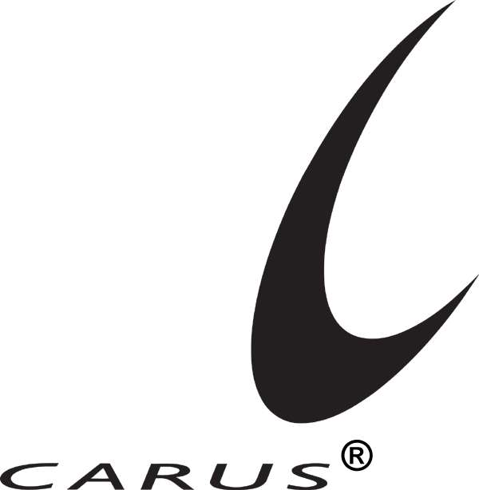 is a registered service mark of Carus Corporation. CARUS™ is a trademark of Carus Corporation. Responsible Care® is a registered service mark of the American Chemistry Council.

